.Link to this page:
Link to this page: https://tinyurl.com/GenVizAI
RSVP here: https://tinyurl.com/GenAIcourseRSVP

Directions:
In person:
- MIT Room 35-225, corner of Mass Ave and Vassar St, Building 35, 2nd Floor.
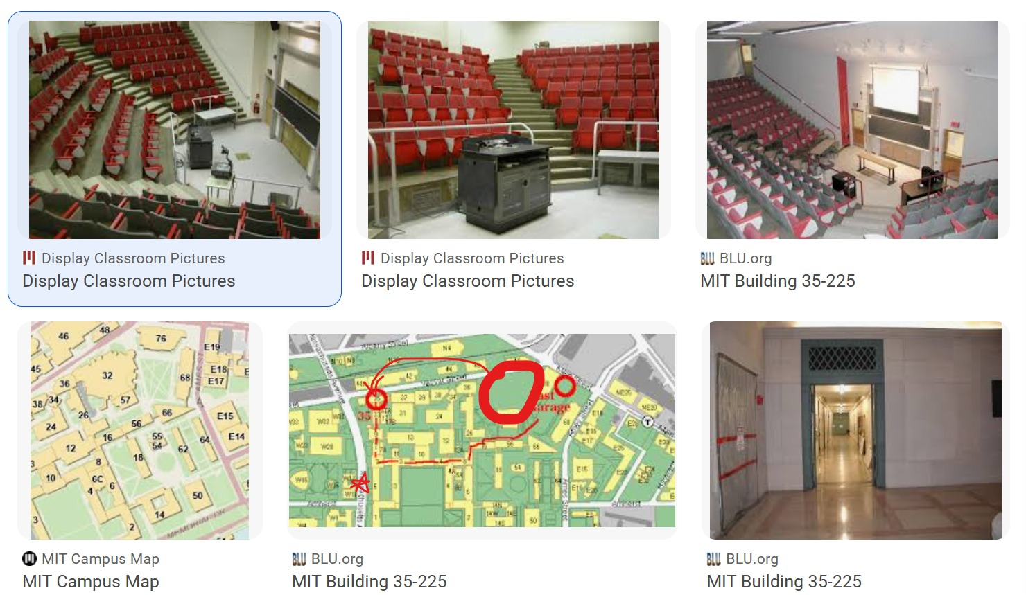
Over zoom:
- https://mit.zoom.us/my/manoli pwd: 2418
- https://mit.zoom.us/my/manoli?pwd=K1FpaGJnSmRhMFE2Z0IzMklsK3MxZz90ca

Week 1
Times:
- M-F Jan 5-9, 2026, 10am-5pm
- Lecture 10am-12pm
- Lunch/Discussion/Break 12-1pm
- Workshop 1pm-5pm
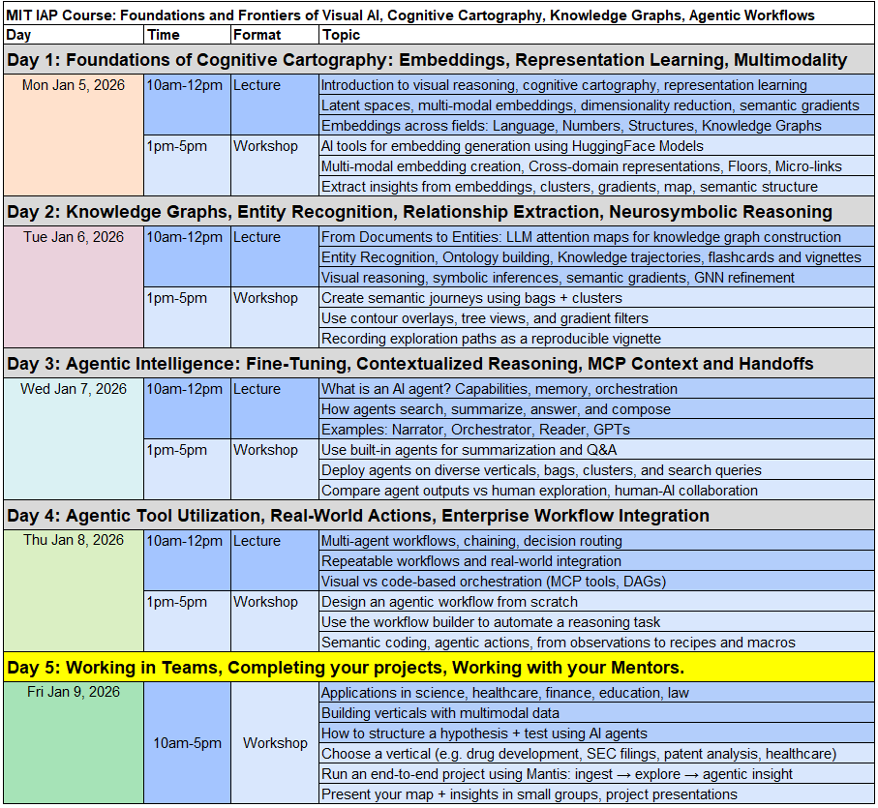

Lecture slides:
- IAP Course | MIT 6.S189 & MIT 6.S187

Workshops:
- Foundations Course - Day 1
- MIT IAP Course 6.S189 | Day 1 Workshop : Mantis.ipynb
- MIT IAP Course 6.S189 | Day 2 Workshop : Knowledge Graphs, Entity Recognition, Relationship Extraction, Neurosymbolic Reasoning

Week 2
Times:
- M-F Jan 12-16, 2026, 4pm-9pm
- Lecture 4pm-6pm
- Workshop 6pm-9pm
- Pizza/Food: 7-8pm
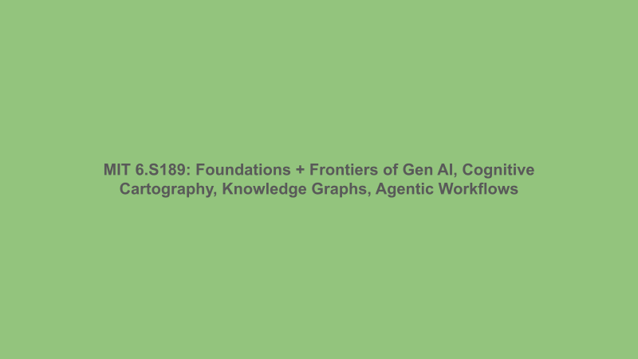
Open preview
